DAY:-2

11. **Find the LCM and GCD of n numbers?**

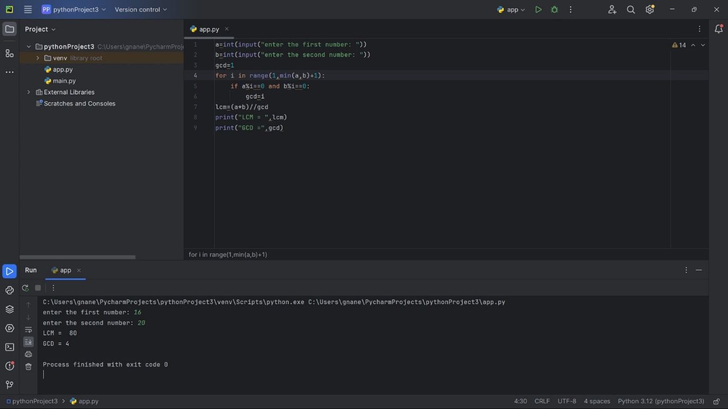

12. **Write a program to convert Decimal number equivalent to Binary number and octal numbers?**

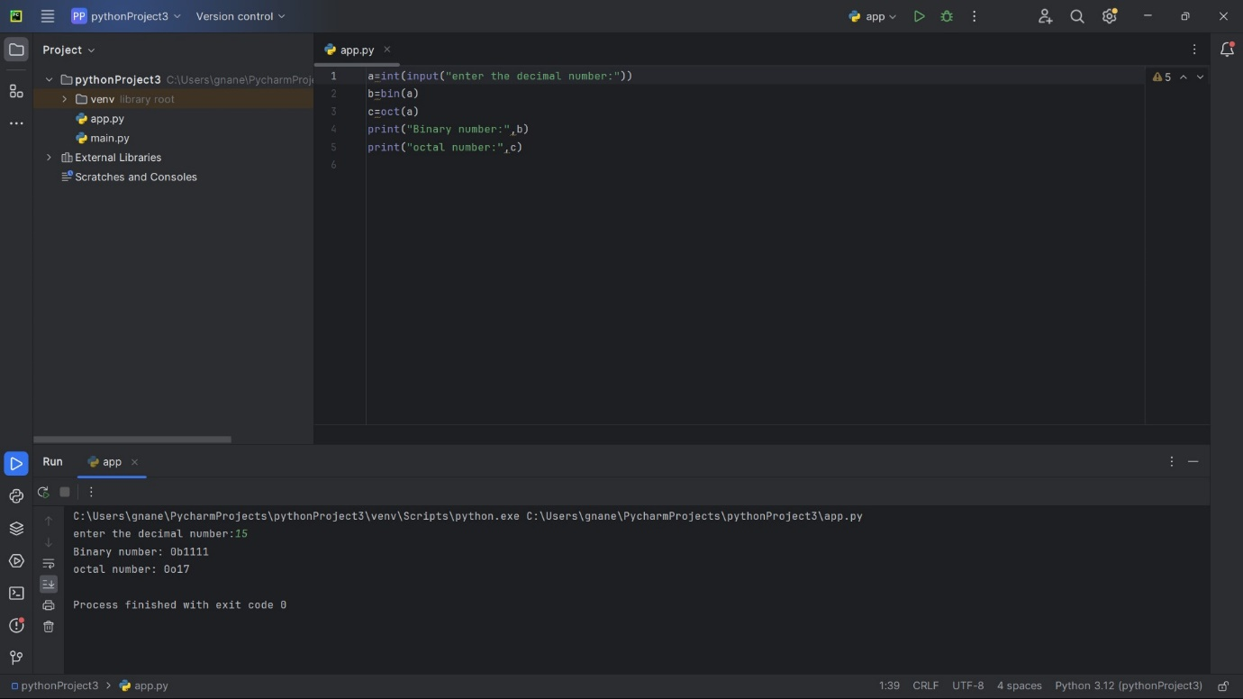

13. **Print the pattern**

**2**

**2 4**

**2 4 6**

**2 4 6 8**

**2 4 6 8 10**

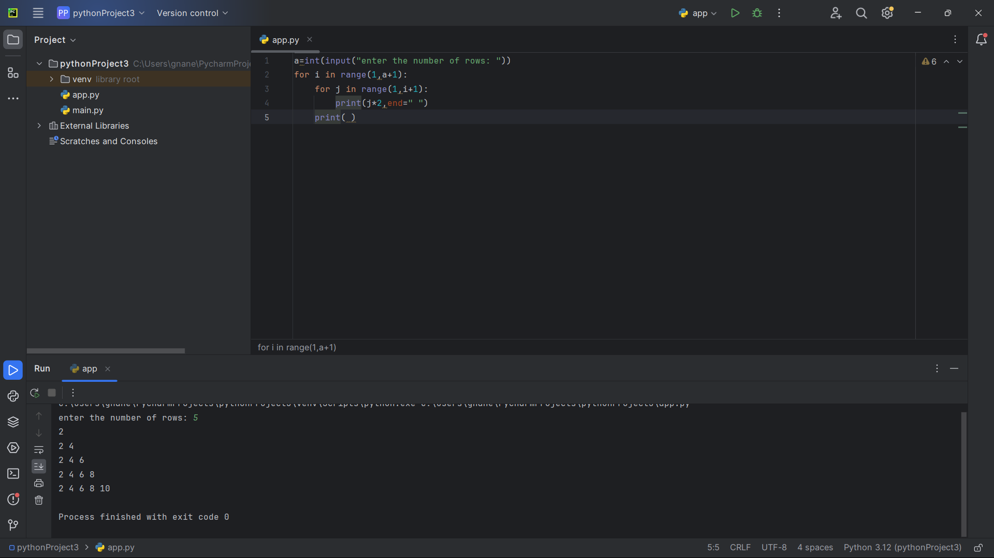

14. **Write a Python Program to remove duplicates from the sorted array**

**Sample Input: Array = {15, 14, 25, 14, 32, 14, 31} Sample Output: Sorted Array = {14, 15, 25, 31, 32}**

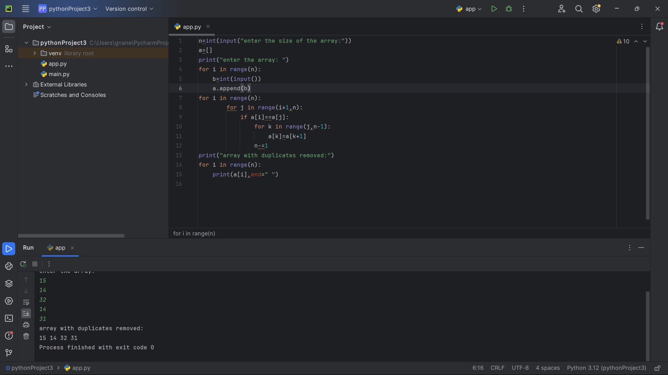

15. **Write a program to find the number of special characters in the given statement.**

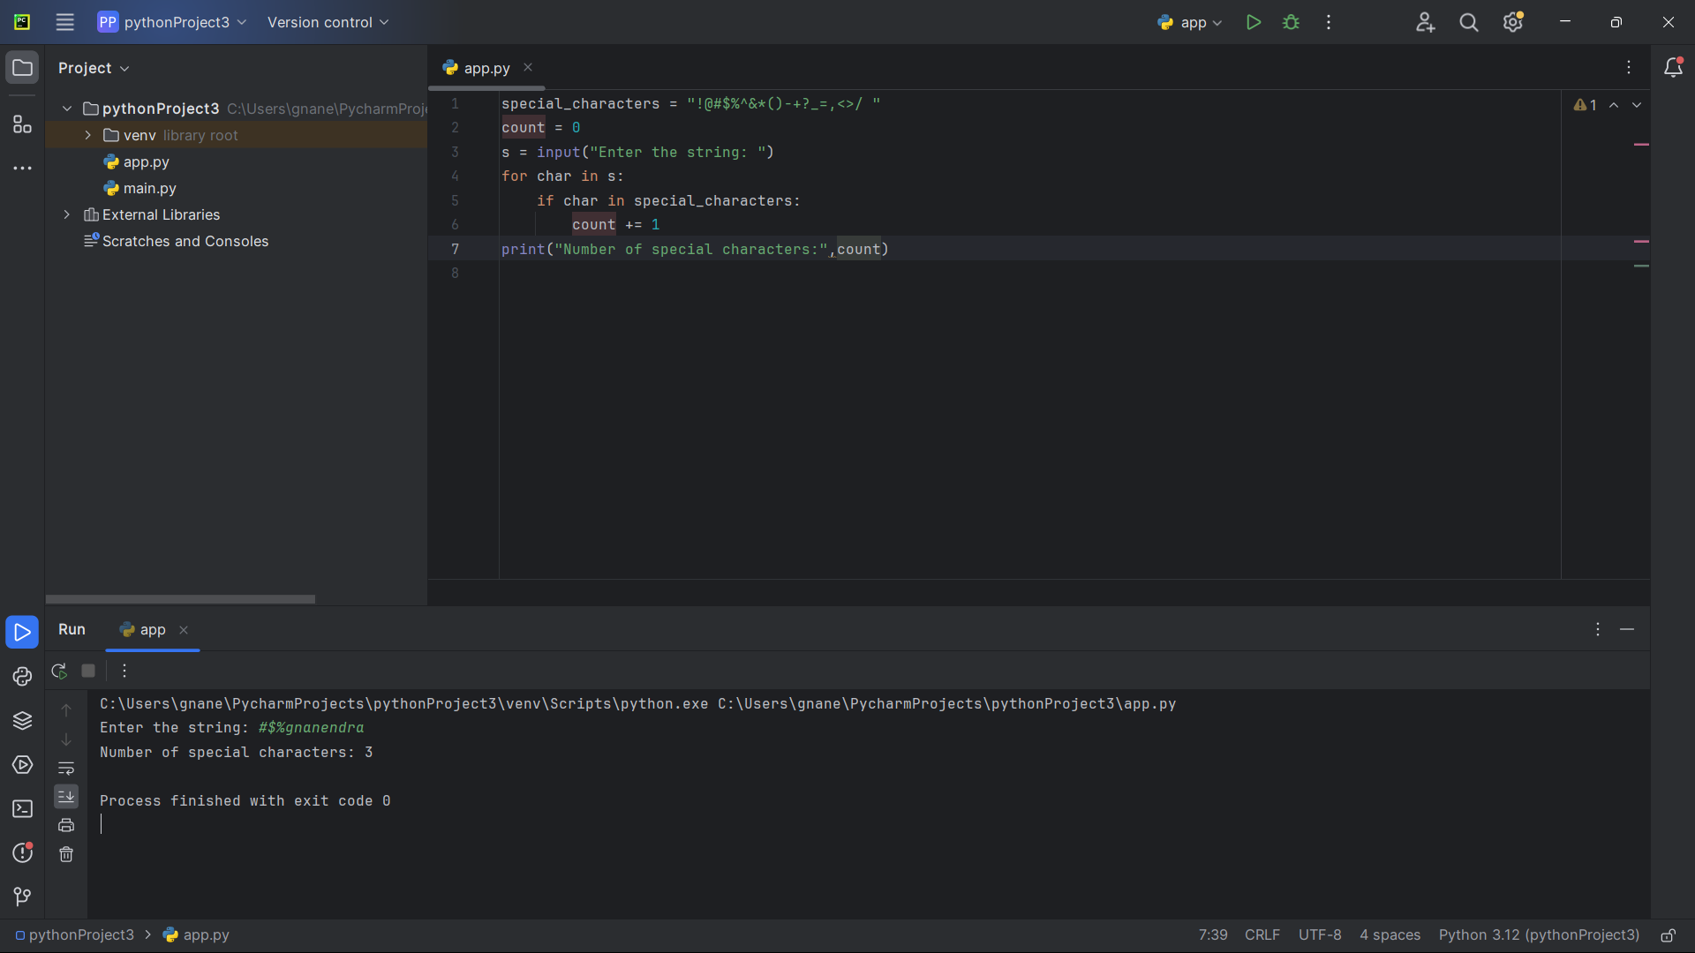

16. **Write a program to count all the prime and composite numbers entered by the user. Sample Input:**

**Enter the numbers 4 , 54 29 71 7 59 98 23**

**Sample Output:**

**Composite number:3 Prime number:5**

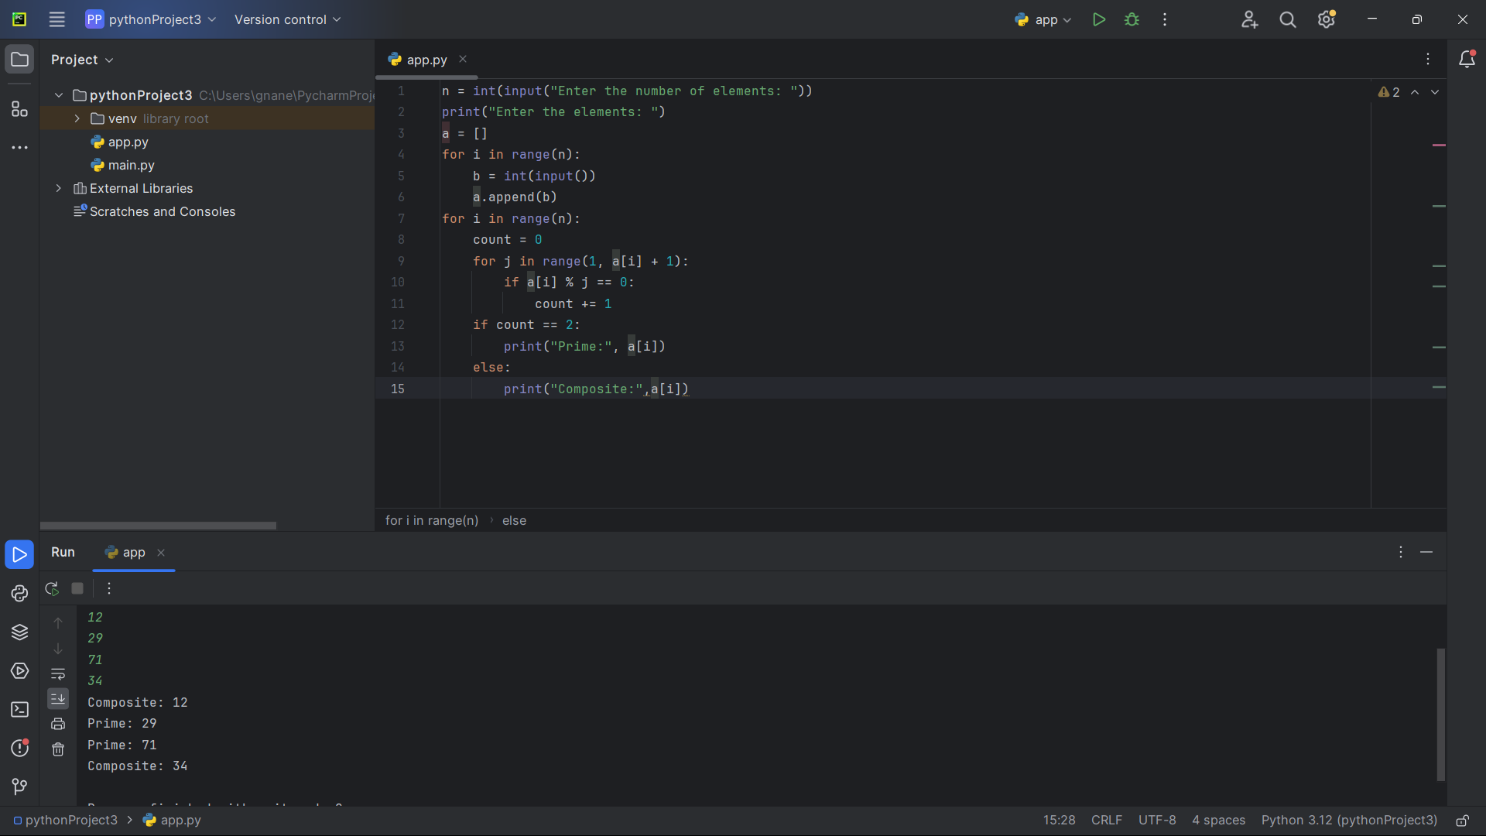

17. **Write a program to print the numbers from M to N by skipping K numbers in between?**

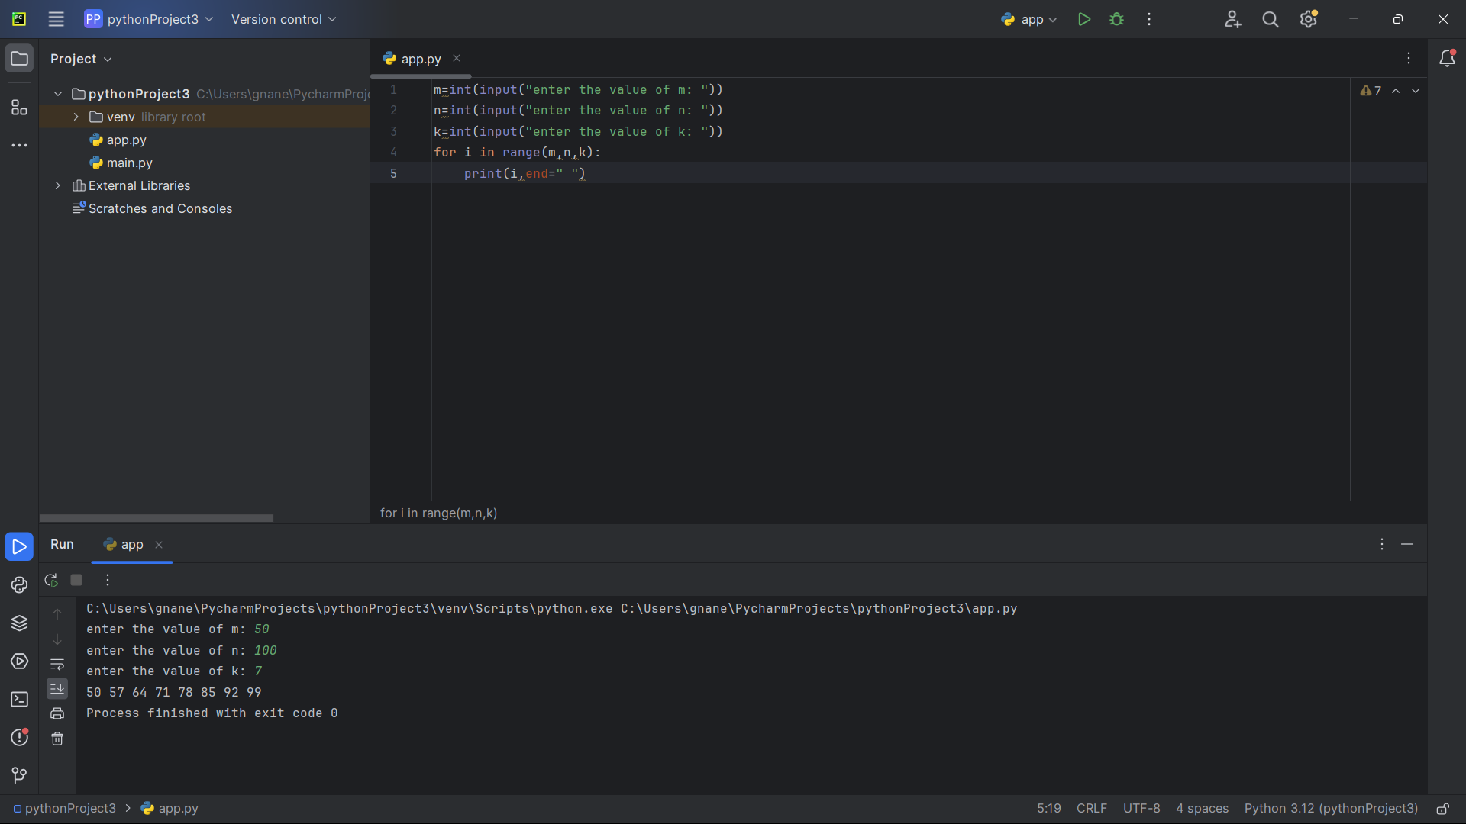

18. **Write a program for matrix addition?**

r = int(input("Enter the number of rows: "))  
c = int(input("Enter the number of columns: "))  
matrix1 = [[0 for j in range(c)] for i in range(r)]  
matrix2 = [[0 for j in range(c)] for i in range(r)]  
print("Enter the elements of matrix-1")  
for i in range(r):  
 for j in range(c):  
 matrix1[i][j] = int(input())  
print("Enter the elements of matrix-2")  
for i in range(r):  
 for j in range(c):  
 matrix2[i][j] = int(input())  
result_matrix = [[0 for j in range(c)] for i in range(r)]  
for i in range(r):  
 for j in range(c):  
 result_matrix[i][j] = matrix1[i][j] + matrix2[i][j]  
print("Resultant Matrix:")  
for i in range(r):  
 for j in range(c):  
 print(result_matrix[i][j], "\t", end="")  
 print()

**19. Write a program that would sort a list of names in alphabetical order Ascending or Descending, choice get from the user?**

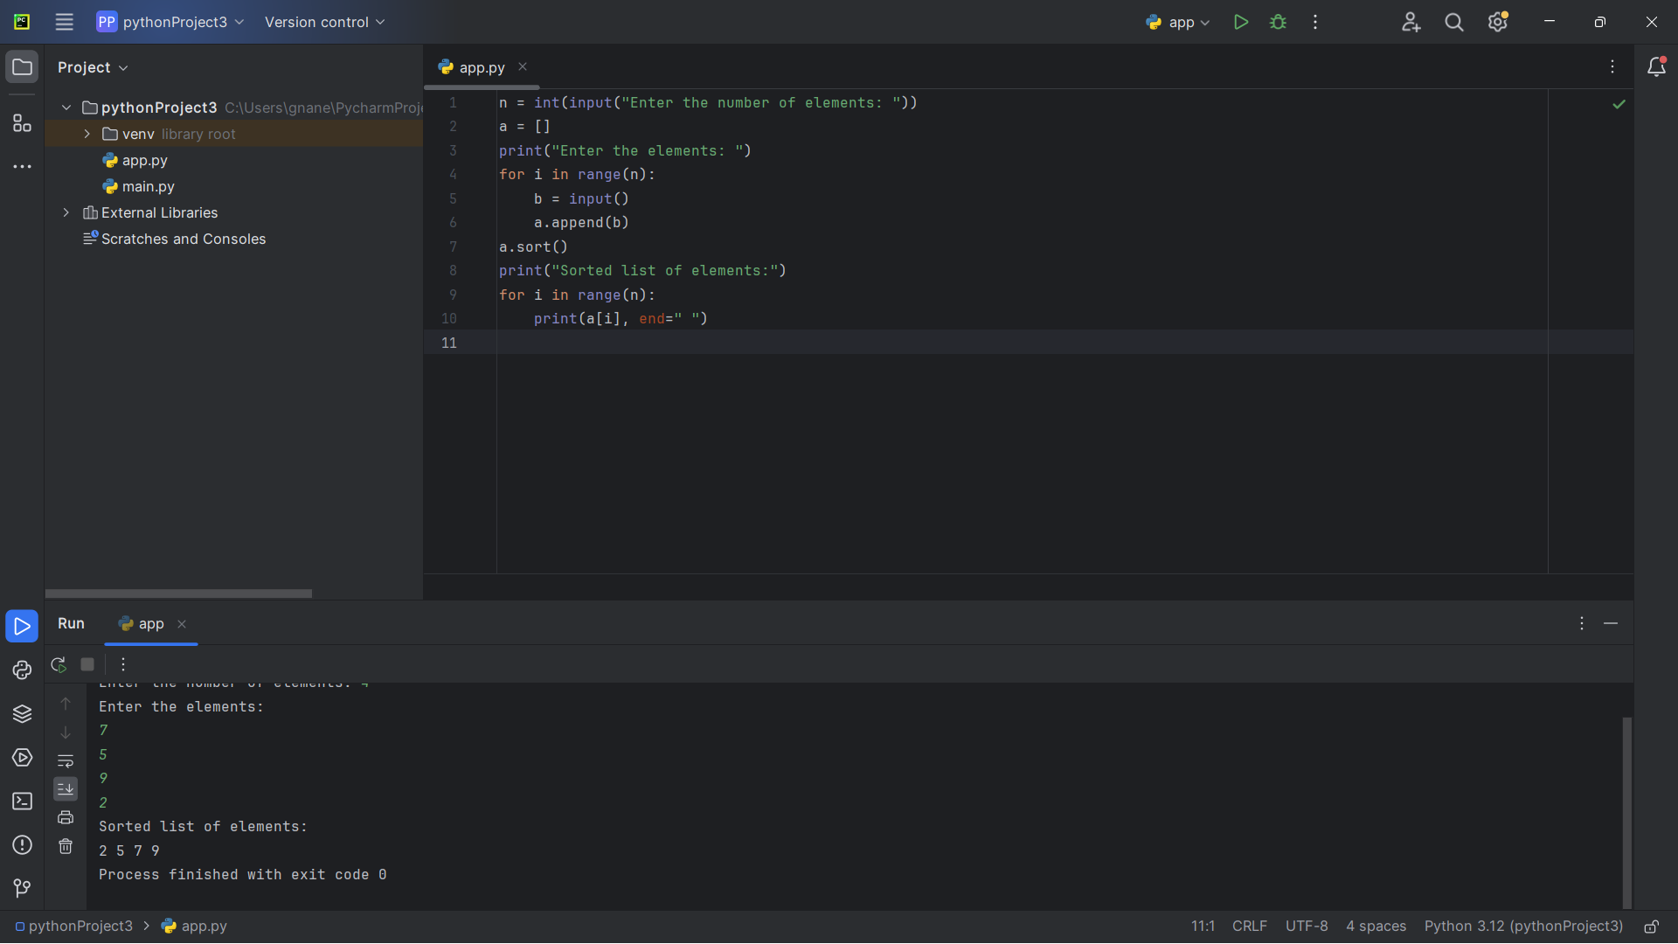

**20. Write a program to print the multiplication table of number m up to n.**

